

Hans Raj Mahila Maha Vidyalaya, Jalandhar

7.1.4 Water conservation facilities available in the Institution-Other Relevant Information:
- Geo-tagged photographs

Rainwater Harvesting https://www.hrmmv.org/rainwaterharvesting.php
Water tank
https://www.hrmmv.org/watertank.php
RO systems
https://www.hrmmv.org/ro.php
Waste water recyclying
https://www.hrmmv.org/liquidwaste.php

Water conservation facilities available in the Institution
S.No | Facility | Usage | Photograph | Geo-tag location
1. | Rain Water Harvesting units | The college has installed 11 rain Water Harvesting Units at strategic locations. Technology used is Seechewal Method for ground water recharging.  Specifications:  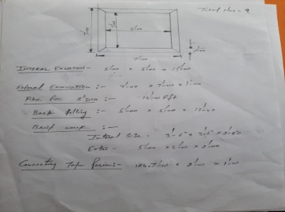  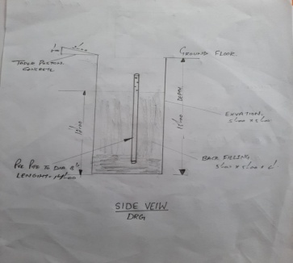 | 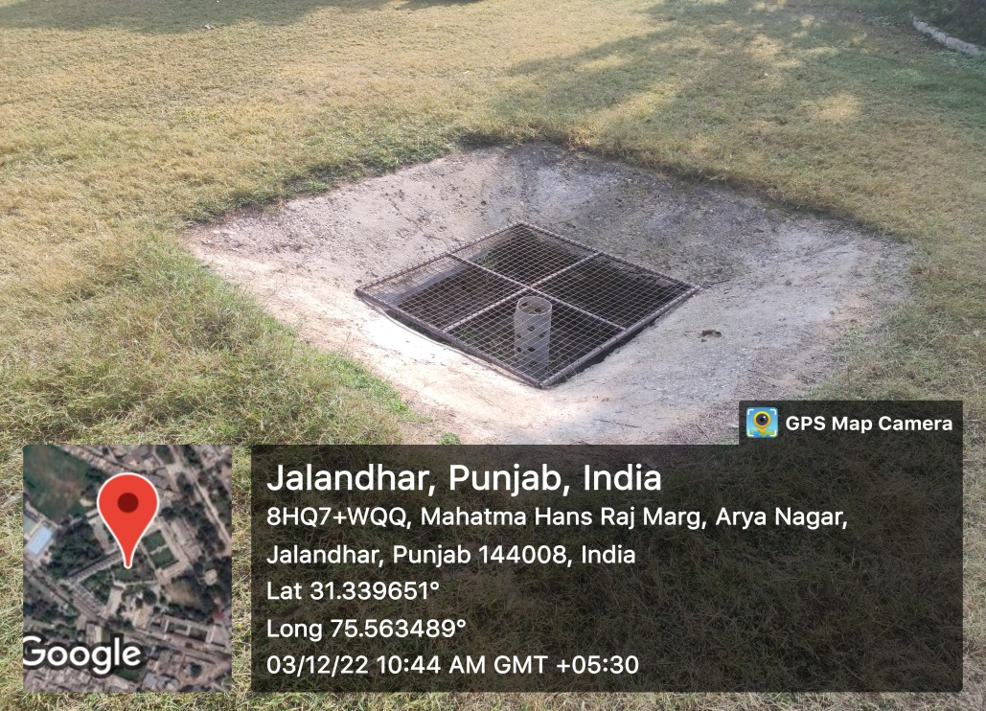  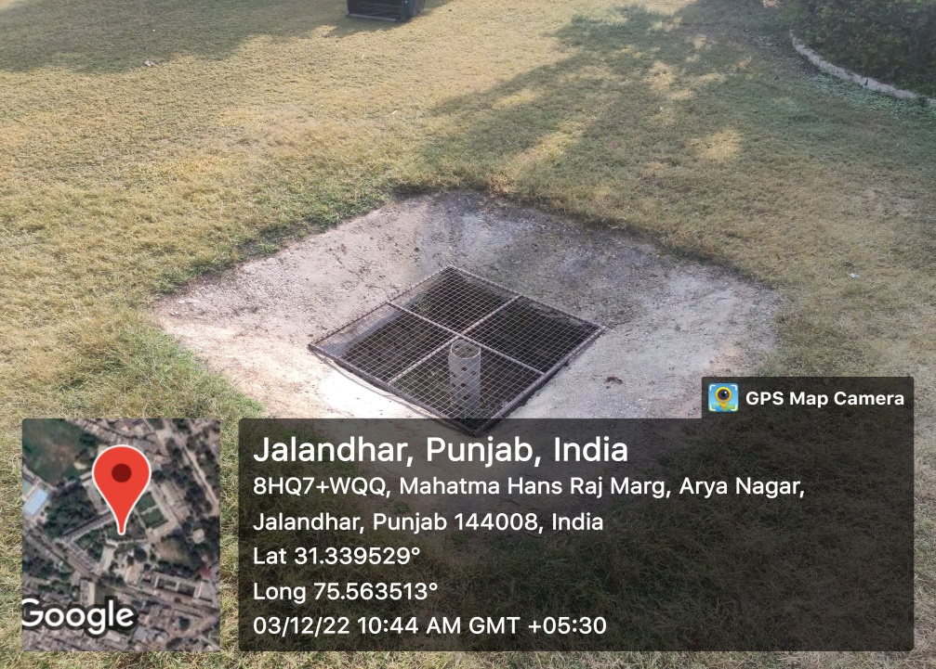  https://www.hrmmv.org/rainwaterharvesting.php
2. | Borewell | Presence of a borewell has ensured twenty four hours water supply in the campus without any interruption. | 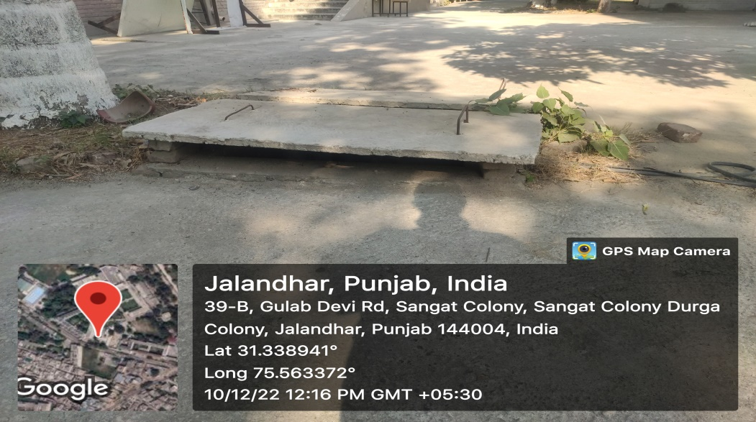
3. | Water Tank | The college has a water tank of capacity 1 Lac litres. Regular cleaning of the tank is done to ensure good health and hygiene. | 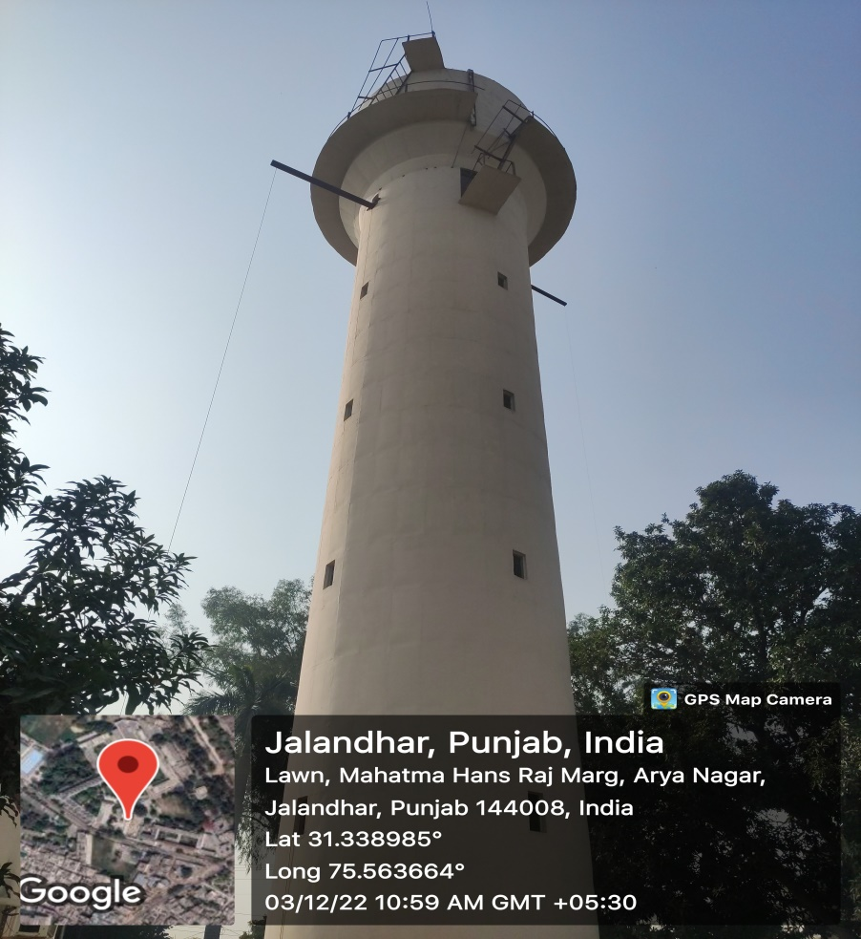  https://www.hrmmv.org/watertank.php
4. | Waste Water recycling | Liquid waste from air conditioners is collected in small tanks and is used for watering plants and sweeping floors.  Liquid waste from the washbasins at the upper floors is used for filling up the toilet flush tanks.  . | Waste water from ACs being used to water plants  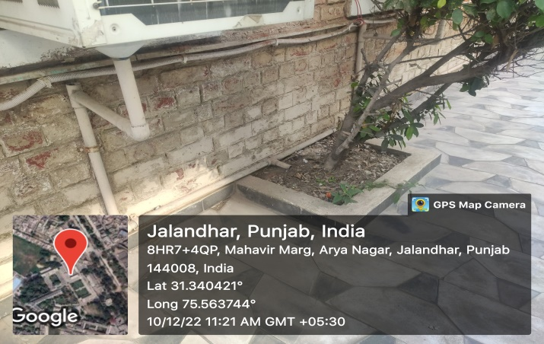  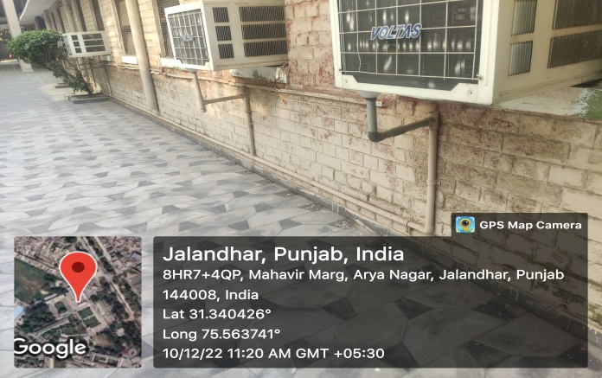  Waste water from ACs being used for sweeping floors  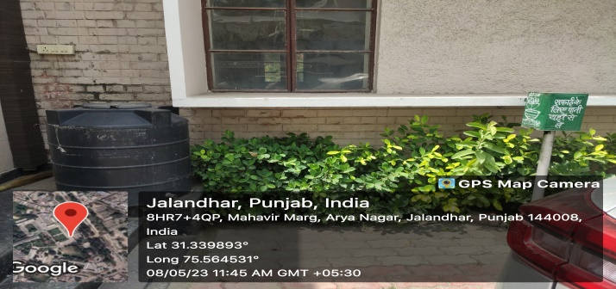  The liquid waste from chemistry lab is carefully recovered through distillation process.  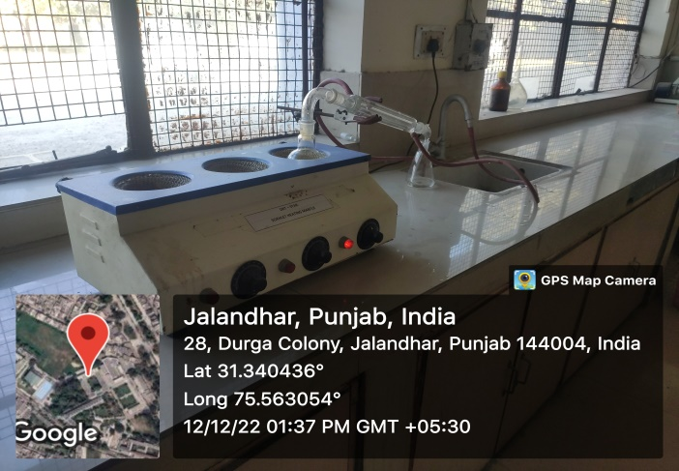  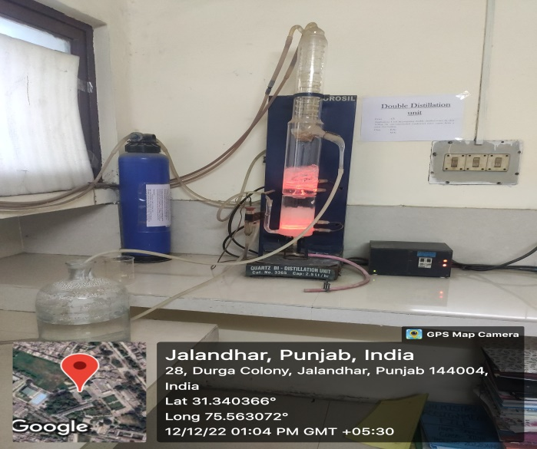  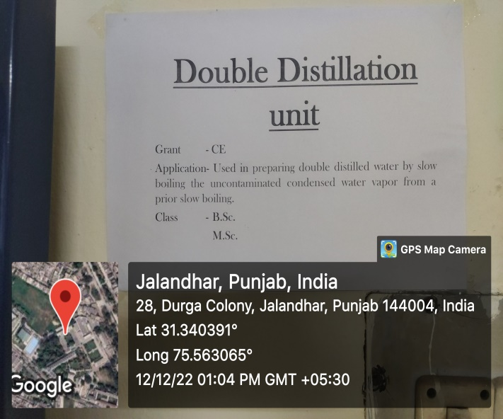  Liquid waste from the washbasins at the upper floors is used for filling up the toilet flush tanks  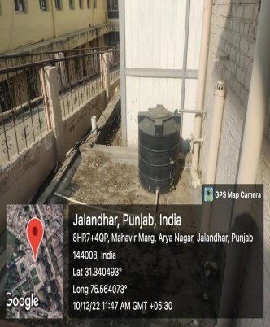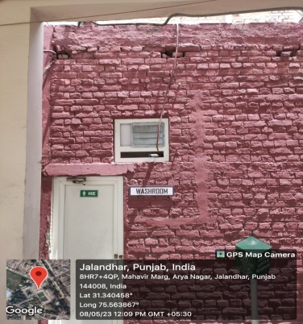  Waste RO Water is saved &reused  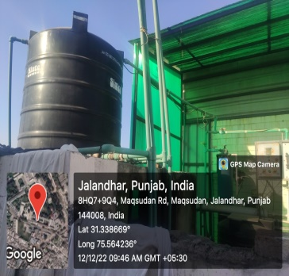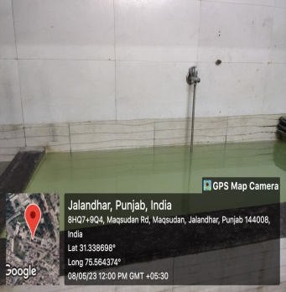  https://www.hrmmv.org/watertank.php
5. | Maintenance of water bodies and distribution system in the campus | A total of around 20 RO systems have been installed in the campus to ensure healthy drinking water. Their maintenance and cleaning is regularly done.. | 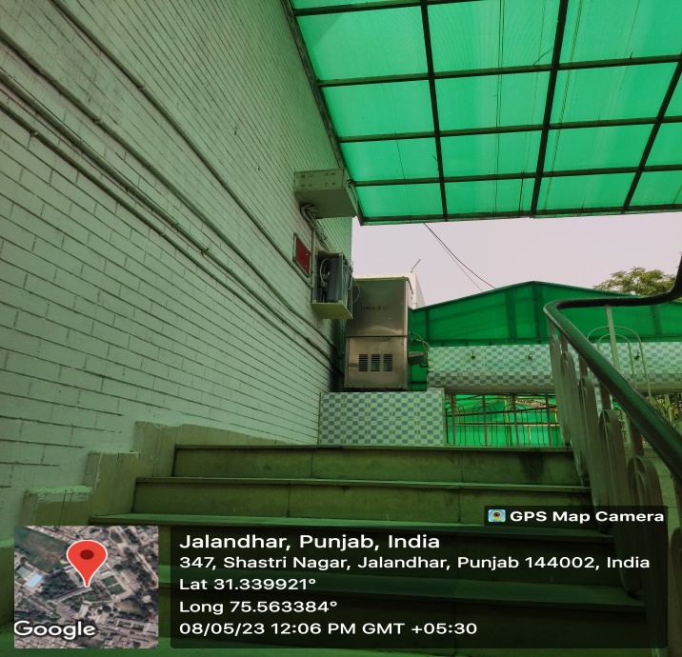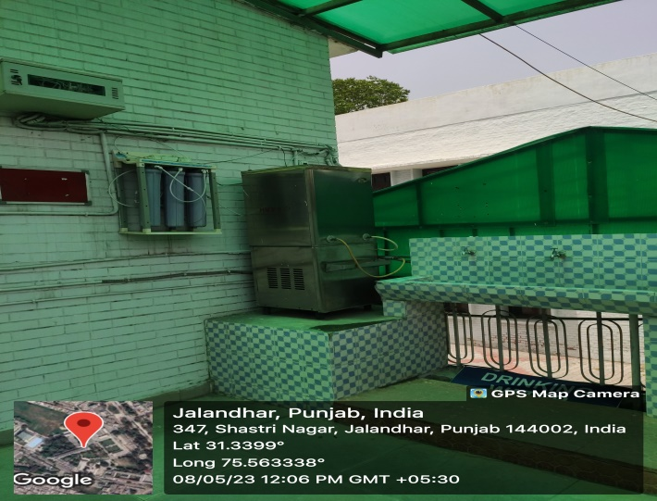  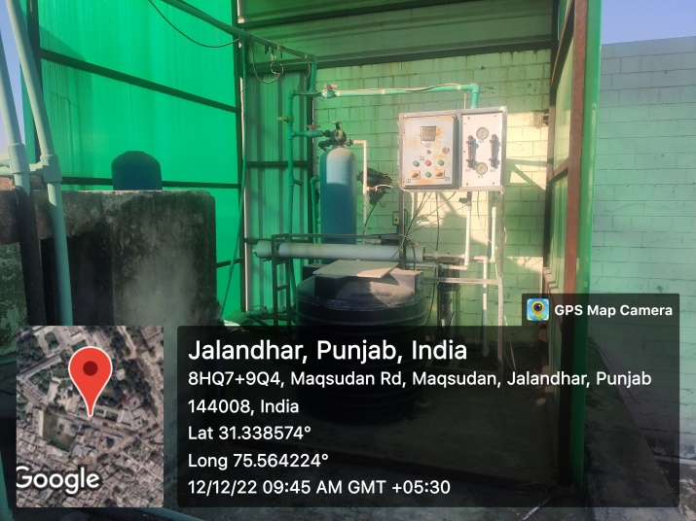  RO Unit installed at one place in the hostel from where water is distributed to various places for drinking inside the hostel  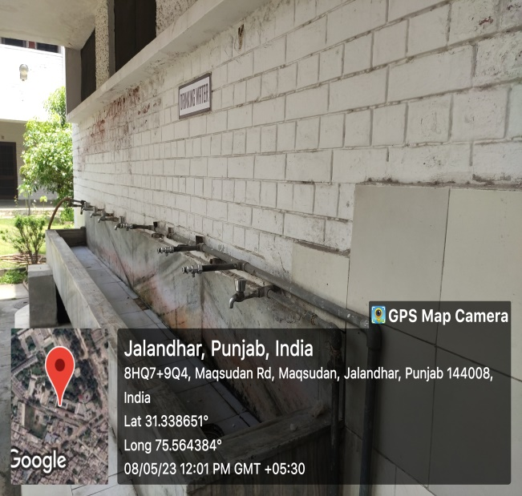  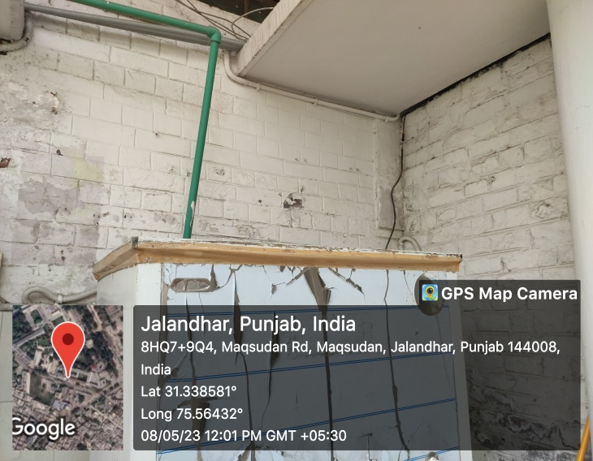  https://www.hrmmv.org/ro.php

